Project Design Phase-II
Technology Stack (Architecture & Stack)
Date | 27 September 2026
Team ID | 6ab229b877181cf94a22636a
Project Name | AI WeatherWise
Maximum Marks | 4 Marks
Technical Architecture:
The architectural diagram and the supporting details are provided below, per Table-1 and Table-2.
AI WeatherWise: Location-based current weather with AI-generated, personalized insight
Reference: https://developer.ibm.com/patterns/ai-powered-backend-system-for-order-processing-during-pandemics/
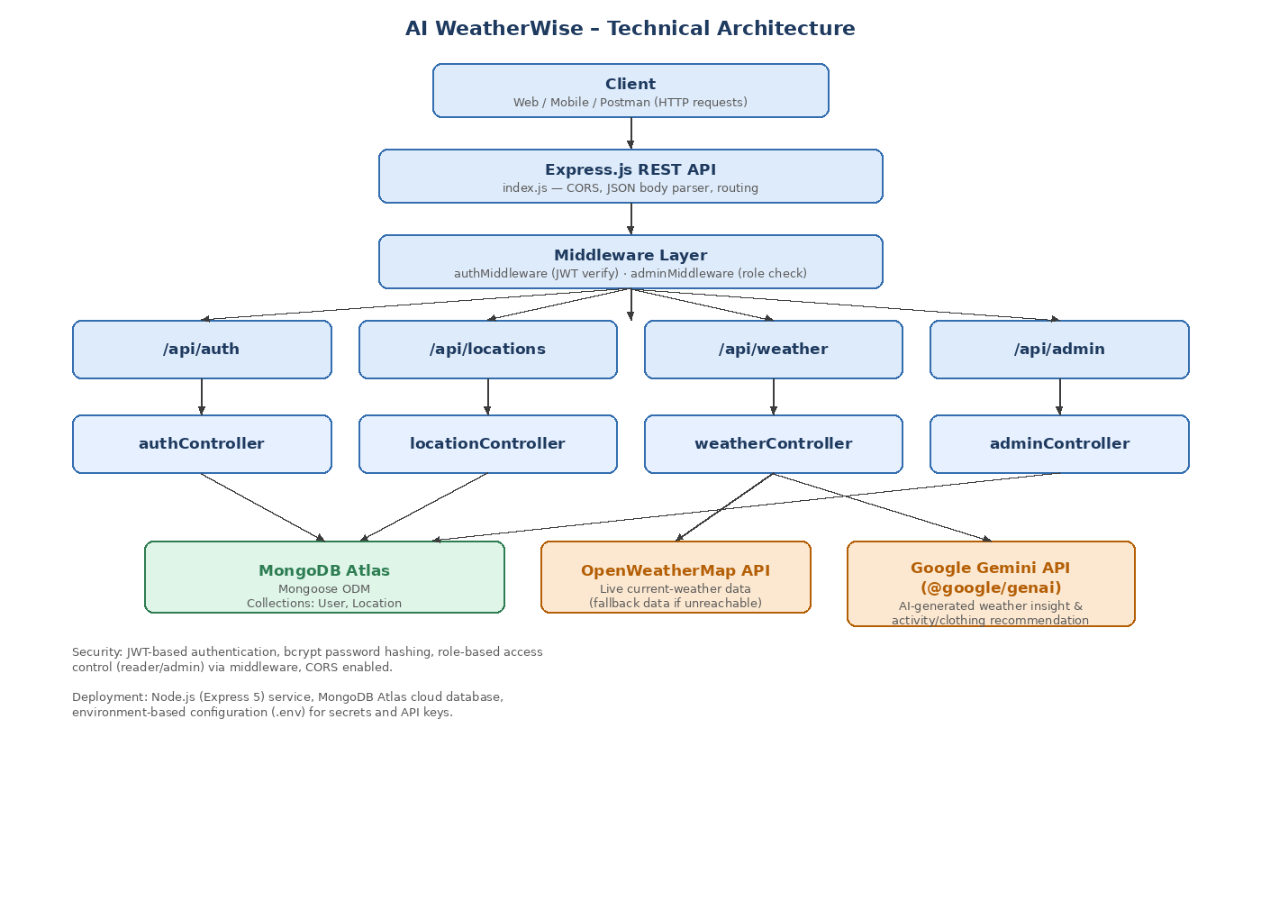
Table-1 : Components & Technologies:
S.No | Component | Description | Technology
1. | User Interface | Client that consumes the REST API and lets users register/login, manage saved locations, and view weather + AI insights. | REST client (Web / Mobile / Postman) over HTTPS, JSON
2. | Application Logic-1 (Auth) | User registration, login and JWT issuance; password hashing. | Node.js, Express.js, authController.js, bcryptjs, jsonwebtoken
3. | Application Logic-2 (Locations) | Add, list, update and delete a user's saved locations (city/country), scoped to the logged-in user. | Node.js, Express.js, locationController.js, Mongoose
4. | Application Logic-3 (Weather & AI Insight) | Fetches current weather for a city and generates a natural-language, personalized weather insight. | weatherController.js, OpenWeatherMap REST API, Google Gemini (@google/genai)
5. | Database | Stores user accounts (with role) and each user's saved locations. | MongoDB, Mongoose ODM (User, Location schemas)
6. | Cloud Database | Managed cloud-hosted MongoDB instance, connected via a URI stored in environment variables. | MongoDB Atlas
7. | File Storage | Multer is included for handling multipart/form-data / file uploads if the project requires image or document uploads. | Multer (local filesystem) — not yet used by an active route
8. | External API-1 | Fetches real-time current weather conditions for a requested city; falls back to static sample data if the provider is unreachable or the key is missing. | OpenWeatherMap Current Weather API
9. | External API-2 | Generates an AI natural-language weather summary and activity/clothing recommendations from the fetched weather data. | Google Gemini API via @google/genai SDK
10. | Machine Learning / GenAI Model | Large language model used purely for generative natural-language insight (not a custom-trained ML model). | Gemini (gemini-3.6-flash) generative model
11. | Infrastructure (Server / Cloud) | Application runs as a Node.js Express server; deployable locally or to any Node-compatible cloud host.  Local Server Configuration: Node.js runtime, npm run dev (nodemon) on PORT from .env.  Cloud Server Configuration: Node.js hosting (e.g. Render / Railway / AWS / Azure) + MongoDB Atlas. | Node.js, Express 5, nodemon (dev), Local / Cloud hosting

Table-2: Application Characteristics:
S.No | Characteristics | Description | Technology
1. | Open-Source Frameworks | Core web framework, ODM, and supporting libraries used to build the backend. | Express.js, Mongoose, bcryptjs, jsonwebtoken, cors, dotenv, multer, nodemon
2. | Security Implementations | Passwords are hashed before storage; routes are protected by JWT verification; admin-only routes are additionally role-checked; cross-origin requests are explicitly enabled/controlled. | bcryptjs (password hashing), JSON Web Tokens (JWT), custom auth/admin middleware, CORS
3. | Scalable Architecture | Layered (routes → middleware → controllers → models) architecture separates concerns, so each layer can be modified or scaled independently; stateless JWT auth allows the API to run behind multiple instances/load balancers. | 3-tier architecture (Client → Node.js/Express API → MongoDB), stateless REST
4. | Availability | MongoDB Atlas provides a managed, replicated cloud database; the stateless Express API can be run as multiple instances behind a load balancer for higher availability; the weather endpoint returns fallback data instead of failing when the external provider is down. | MongoDB Atlas (replica set), horizontal scaling of Node.js instances, graceful fallback responses
5. | Performance | JSON body parsing and lightweight middleware keep request handling fast; Mongoose queries are scoped/indexed by user; the weather/AI insight flow degrades to fast local fallback logic instead of blocking on slow external calls. | Express.js, Mongoose (MongoDB indexes), fallback responses to avoid slow external dependency wait

References:
https://c4model.com/
https://developer.ibm.com/patterns/online-order-processing-system-during-pandemic/
https://www.ibm.com/cloud/architecture
https://aws.amazon.com/architecture
https://medium.com/the-internal-startup/how-to-draw-useful-technical-architecture-diagrams-2d20c9fda90d

